Sample Project Documentation
Field | Details
Date | 01 October 2026
Team ID | SWTID-2026-4935
Project Name | ComicCraft - AI Comic Story Creator

ComicCraft - AI Comic Story Creator
Project Description: ComicCraft is a FastAPI-based generative AI application that turns a user-provided story idea into a five-panel illustrated comic. The user selects a main character, setting, story tone and art style. Gemini-based services create a structured five-panel outline and expand each panel with a caption, narration and dialogue. An image-generation service creates artwork for each panel. The resulting panels are shown in a browser preview and compiled into a downloadable PDF.
Technical Summary: The application uses Python, FastAPI, Uvicorn, Jinja2, Pydantic, google-genai, Pillow and FPDF2. Image generation can use local Diffusers or Hugging Face Spaces/router integrations with FLUX and Stable Diffusion options. API keys are configured through environment variables.

Scenarios
Scenario | Description
Scenario 1 | A user enters a story idea, names a character and selects creative settings. ComicCraft generates five connected panels, story text and images.
Scenario 2 | A user runs DEMO_MODE=true. External AI calls are skipped, placeholder panels are produced, and the preview/PDF workflow still runs.
Scenario 3 | An image provider becomes unavailable. ComicCraft records a warning and can fall back to another provider/backend or create a labelled placeholder.

Figure: ComicCraft System Architecture

Technical Architecture
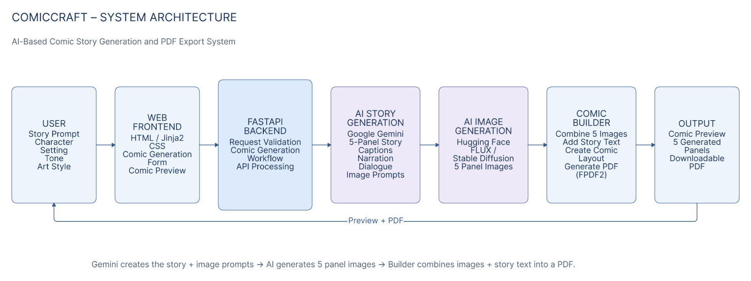
Layer | Implementation
Client / Presentation | HTML + Jinja2 + CSS; index.html, comic_preview.html, export_success.html.
API / Application | FastAPI routes served by Uvicorn.
AI Text | Gemini outline/story services using google-genai and configurable fallback models.
AI Image | Local Diffusers or Hugging Face Spaces/router with FLUX/Stable Diffusion options.
Orchestration | workflow.py coordinates outline → story → images → layout → PDF.
Storage | JPEG panel files in static/panels and PDFs in static/exports.

No relational or document database is used by the supplied implementation, so an ER diagram is not required.

Pre-requisites
- Python 3.10+
- FastAPI/Uvicorn development knowledge
- Jinja2/HTML/CSS basics
- Python/Pydantic fundamentals
- Google Gemini API configuration for live text generation
- Hugging Face or local Diffusers configuration for live image generation
- pytest/httpx for automated testing

Project Workflow

Milestone 1: Model Selection and Architecture
- Define five-panel workflow and input schema.
- Configure Gemini model lists and image backend settings.
- Separate presentation, API, service and file-storage layers.

Milestone 2: Core Functionalities Development
- Implement PromptRequest and panel models.
- Implement Gemini outline and story services.
- Implement image generation, verification and fallback handling.

Milestone 3: Workflow and Export Development
- Connect outline, story, images, layout and PDF.
- Create five-page A4 PDF output with FPDF2.

Milestone 4: Frontend Development
- Build input form and loading state.
- Render five panel cards and text.
- Embed images as base64 with static fallback.
- Provide download/export-success flow.

Milestone 5: Testing and Reliability
- Use DEMO_MODE for offline smoke testing.
- Use /health and /test-image diagnostics.
- Run pytest coverage for validation, JSON parsing, layout, PDF text safety and routes.

Milestone 6: Conclusion
- Package source with requirements and setup instructions.
- Use preview/PDF flow as final user-facing artifact.

Key Implementation Details

Gemini Outline Generation
gemini_flash.py requests exactly five connected panels with a beginning, development, conflict, climax and ending, and asks for consistent character descriptions in image prompts. JSON is parsed and validated with Pydantic.

Story Expansion
gemini_pro.py preserves panel identity and image prompts while adding caption, narration and dialogue. It also normalizes list-valued dialogue into text.

Image Generation and Fallbacks
image_generator.py verifies saved JPEGs, detects nearly blank images, supports local Diffusers and Hugging Face paths, and can create labelled placeholders when generation fails.

Preview and Export
routes.py embeds images as base64 data URIs with static fallback. exporters.py creates an A4 PDF with one panel per page and includes scene, caption, narration and dialogue.

Automated Testing Evidence
During documentation review, tests/test_core.py and tests/test_app.py were executed together: 10 tests passed. Two FastAPI deprecation warnings were reported for the startup event API.

Representative Generated Output
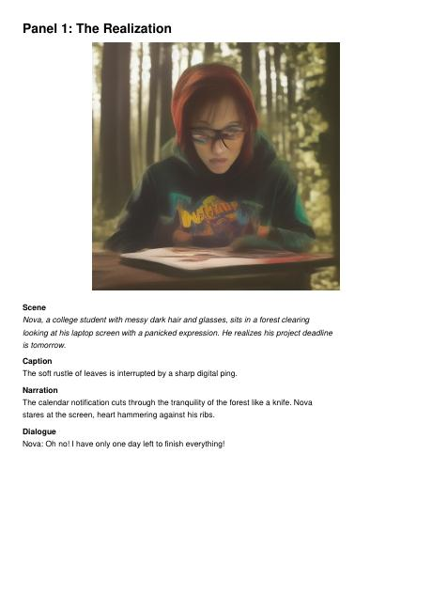
Actual generated ComicCraft PDF page from the supplied project ZIP — Panel 1.
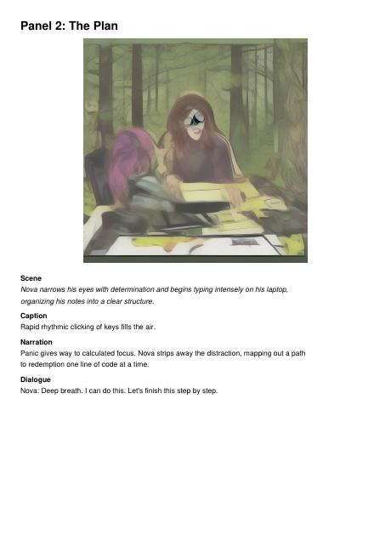
Actual generated ComicCraft PDF page from the supplied project ZIP — Panel 2.
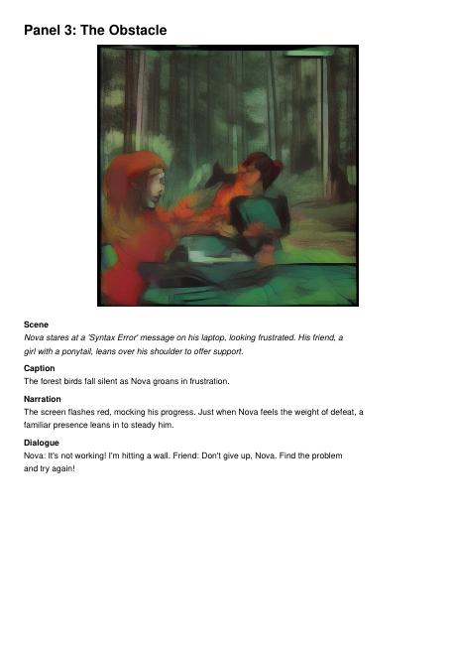
Actual generated ComicCraft PDF page from the supplied project ZIP — Panel 3.
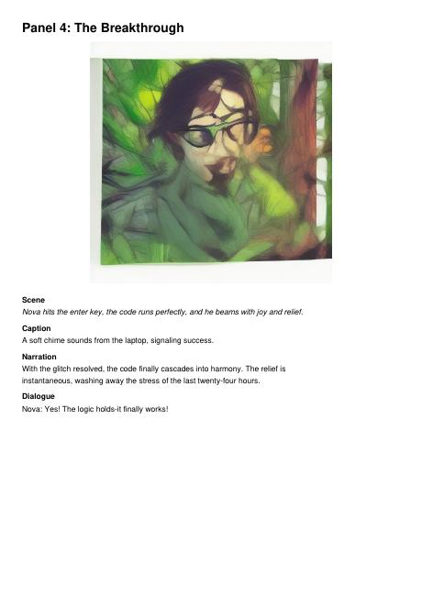
Actual generated ComicCraft PDF page from the supplied project ZIP — Panel 4.
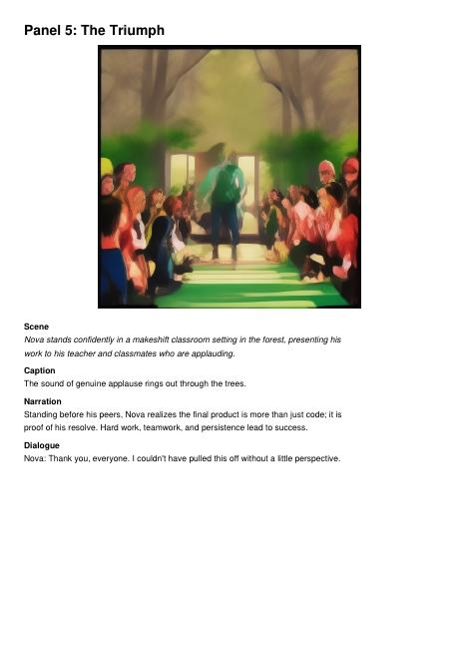
Actual generated ComicCraft PDF page from the supplied project ZIP — Panel 5.

Conclusion
ComicCraft combines generative text, image generation, web presentation and document export into a single five-panel comic workflow. The supplied source demonstrates modular FastAPI services, configurable Gemini and image backends, preview reliability, PDF export, demo mode and automated tests. Future enhancements can add persistent history, authentication, stronger performance benchmarking, additional art/model choices and production deployment.

